
Labor Market REVIEW
Statistical Data for Mar. 2008 Economic Growth Region 4 May 2008

LABOR FORCE ESTIMATES
March 2008 Preliminary Unemployment Rates

AREA | LABOR FORCE | EMPLOYED | UNEMPLOYED | 03/08 | 02/08 | 03/07
U.S. | 153,135,000 | 145,108,000 | 8,027,000 | 5.2 | 5.2 | 4.5
INDIANA | 3,207,412 | 3,028,296 | 179,116 | 5.6 | 5.3 | 4.9
Economic Growth Region 4* | 237,915 | 224,232 | 13,683 | 5.8 | 5.3 | 4.8
Kokomo MSA** | 44,991 | 41,748 | 3,243 | 7.2 | 6.7 | 5.7
Lafayette MSA*** | 96,653 | 91,860 | 4,793 | 5.0 | 4.6 | 4.1
Benton County | 4,646 | 4,402 | 244 | 5.3 | 5.0 | 4.6
Carroll County | 10,652 | 10,108 | 544 | 5.1 | 4.7 | 4.4
Cass County | 18,519 | 17,366 | 1,153 | 6.2 | 5.9 | 4.9
Clinton County | 16,813 | 15,831 | 982 | 5.8 | 5.6 | 5.1
Fountain County | 8,473 | 8,029 | 444 | 5.2 | 4.9 | 4.7
Howard County | 37,283 | 34,530 | 2,753 | 7.4 | 6.7 | 5.8
Miami County | 16,497 | 15,250 | 1,247 | 7.6 | 6.8 | 5.9
Montgomery County | 19,194 | 18,307 | 887 | 4.6 | 4.3 | 4.1
Tippecanoe County | 81,355 | 77,350 | 4,005 | 4.9 | 4.5 | 4.1
Tipton County | 7,708 | 7,218 | 490 | 6.4 | 6.3 | 5.3
Warren County | 4,731 | 4,543 | 188 | 4.0 | 3.8 | 3.7
White County | 12,044 | 11,298 | 746 | 6.2 | 5.8 | 5.0
Attica City | 1,626 | 1,551 | 75 | 4.6 | 5.8 | 3.7
Crawfordsville City | 7,334 | 6,936 | 398 | 5.4 | 5.1 | 5.5
Delphi City | 1,433 | 1,355 | 78 | 5.4 | 4.9 | 5.7
Fowler City | 1,115 | 1,064 | 51 | 4.6 | 4.1 | 4.7
Frankfort City | 7,316 | 6,783 | 533 | 7.3 | 7.2 | 6.6
Kokomo City | 20,125 | 18,475 | 1,650 | 8.2 | 8.0 | 6.9
Lafayette City | 33,851 | 31,787 | 2,064 | 6.1 | 4.9 | 4.4
Logansport City | 8,397 | 7,828 | 569 | 6.8 | 6.6 | 6.2
Monticello City | 2,593 | 2,410 | 183 | 7.1 | 7.2 | 6.1
Peru City | 5,769 | 5,290 | 479 | 8.3 | 7.4 | 6.9
Tipton City | 2,447 | 2,256 | 191 | 7.8 | 7.6 | 5.5
Williamsport City | 996 | 964 | 32 | 3.2 | 3.1 | 3.3

REGIONAL AND STATE UNEMPLOYMENT
(SEASONALLY ADJUSTED)
The Bureau of Labor Statistics of the U.S. Department of Labor reported the regional and state unemployment rates were generally higher in March. Overall, 36 states recorded over-the-month unemployment rate increases, 5 states registered decreases and 9 states had no change in their rates. Over the year, jobless rates were up in 39 states, down in 9 states and unchanged in 2 states.
Michigan continued to report the highest state unemployment rate, 7.2 percent. The states with the next highest rates were Alaska, 6.7%; California, 6.2%; Rhode Island, 6.1%; and Mississippi, 6.0%. South Dakota again posted the lowest rate, 2.5%, followed by Nebraska at 2.9%. Overall, 19 states reported unemployment rates that were significantly below the U.S. rate, 5 states recorded measurably higher rates, and 26 states had rates that were statistically little different from that of the nation.

Surrounding States | Unemployment  Rates
March 2008 | (Non-seasonably adjusted)
Illinois | 5.7%
Kentucky | 6.1%
Michigan | 7.9%
Ohio | 6.1%

*EGR 4 includes Benton, Carroll, Cass, Clinton, Fountain, Howard, Miami, Montgomery, Tippecanoe, Tipton, Warren and White counties
**Kokomo MSA includes Howard and Tipton counties
*** Lafayette MSA includes Benton, Carroll and Tippecanoe counties

UNEMPLOYMENT RATE RANKING by COUNTY
(High to Low)
Mar 2008 RANK | COUNTY | Mar  2008 RATE
90 | Warren | 4.0
80 | Montgomery | 4.6
73 | Tippecanoe | 4.9
68 | Carroll | 5.1
65 | Fountain | 5.2
63 | Benton | 5.3
48 | Clinton | 5.8
42 | White | 6.2
38 | Cass | 6.2
34 | Tipton | 6.4
8 | Howard | 7.4
5 | Miami | 7.6

All About Unemployment Rates For a detailed report on how the government measures unemployment rates click on the following link:
http://www.bls.gov/cps/cps_htgm.htm
For the detailed news summary regarding the employment situation in the United States click on the following link: (Adobe Acrobat necessary)
http://www.bls.gov/news.release/pdf/empsit.pdf

LAFAYETTE MSA
(Benton, Carroll, and Tippecanoe Counties)

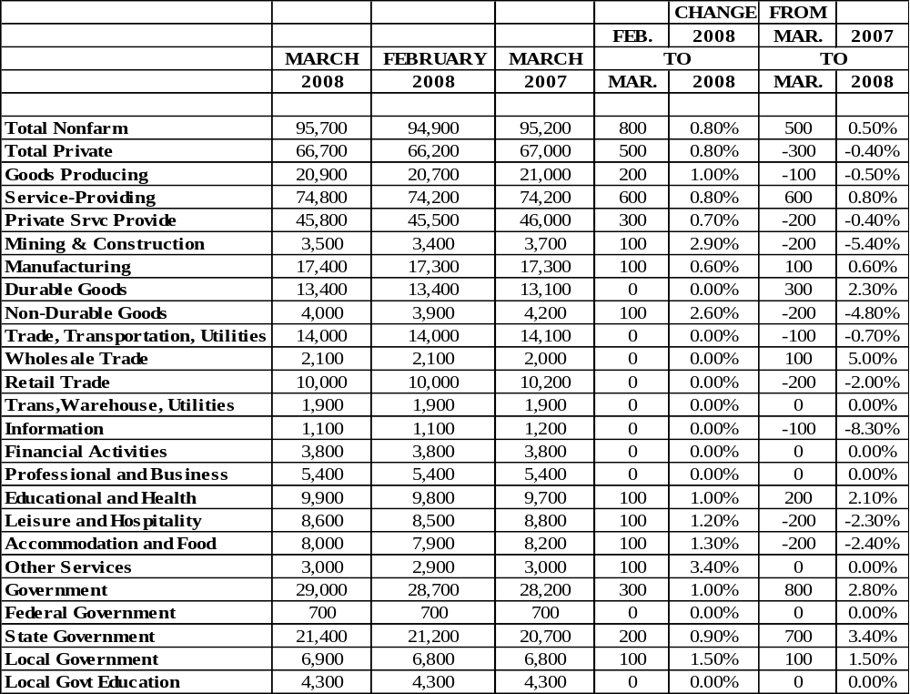

Source: Indiana Workforce Development, Research & Analysis, CES

RESOURCES AND MINING EMPLOYMENT SHOWN ONLY IN TOTAL NONAGRICULTURAL, PRIVATE & GOODS PRODUCING
CONSTRUCTION EMPLOYMENT SHOWN ONLY IN TOTAL NONAGRICULTURAL, PRIVATE & GOODS PRODUCING

Source: Indiana Workforce Development, Research & Analysis, CES

Unofficial/Non BLS area estimates
BLS funding for Anderson MSA was suspended for 2008 but Indiana will continue to estimate.

Source: Indiana Workforce Development, Research & Analysis, CES

WAGE AND SALARIED EMPLOYMENT



KOKOMO MSA
(Howard and Tipton Counties)

WAGE AND SALARIED EMPLOYMENT

North American Industry Classification System

 |  |  |  | CHANGE FROM
 |  |  |  | FEB. | 2008 | MAR. | 2007
 | MARCH | FEBRUARY | MARCH | TO |  | TO
 | 2008 | 2008 | 2007 | MAR. | 2008 | MAR. | 2008
Total Nonfarm | 45,500 | 45,300 | 46,400 | 200 | 0.40% | -900 | -1.90%
Total Private | 37,700 | 37,500 | 38,600 | 200 | 0.50% | -900 | -2.30%
Goods Producing | 14,800 | 14,900 | 15,900 | -100 | -0.70% | -1,100 | -6.90%
Service-Providing | 30,700 | 30,400 | 30,500 | 300 | 1.00% | 200 | 0.70%
Private Srvc Provide | 22,900 | 22,600 | 22,700 | 300 | 1.30% | 200 | 0.90%
Mining & Construction | 1,300 | 1,200 | 1,300 | 100 | 8.30% | 0 | 0.00%
Manufacturing | 13,500 | 13,700 | 14,600 | -200 | -1.50% | -1,100 | -7.50%
Durable Goods | 12,700 | 12,900 | 13,900 | -200 | -1.60% | -1,200 | -8.60%
Transportation Equipment Mfg | 10,500 | 10,700 | 11,600 | -200 | -1.90% | -1,100 | -9.50%
Trade, Transportation, Utilities | 7,400 | 7,300 | 7,400 | 100 | 1.40% | 0 | 0.00%
Wholesale Trade | 1,100 | 1,100 | 1,100 | 0 | 0.00% | 0 | 0.00%
Retail Trade | 5,600 | 5,500 | 5,600 | 100 | 1.80% | 0 | 0.00%
Trans,Warehouse, Utilities | 700 | 700 | 700 | 0 | 0.00% | 0 | 0.00%
Information | 300 | 300 | 300 | 0 | 0.00% | 0 | 0.00%
Financial Activities | 1,500 | 1,500 | 1,400 | 0 | 0.00% | 100 | 7.10%
Professional and Business | 2,900 | 2,900 | 3,000 | 0 | 0.00% | -100 | -3.30%
Educational and Health | 4,200 | 4,200 | 3,900 | 0 | 0.00% | 300 | 7.70%
Leisure and Hospitality | 4,300 | 4,200 | 4,400 | 100 | 2.40% | -100 | -2.30%
Other Services | 2,300 | 2,200 | 2,300 | 100 | 4.50% | 0 | 0.00%
Government | 7,800 | 7,800 | 7,800 | 0 | 0.00% | 0 | 0.00%
State Government | 1,000 | 1,000 | 1,000 | 0 | 0.00% | 0 | 0.00%
Local Government | 6,500 | 6,500 | 6,500 | 0 | 0.00% | 0 | 0.00%
Local Govt Education | 2,900 | 2,900 | 2,900 | 0 | 0.00% | 0 | 0.00%
Anderson, Columbus, Kokomo and Michigan City Metropolitan Statistical Areas are currently published as unofficial/Non-BLS area estimates. BLS funding for these MSAs was suspended for 2008 but Indiana will continue to estimate for these areas.
Source: Indiana Workforce Development, Research & Analysis, CES

*Unofficial/Non BLS area estimates
BLS funding for Anderson MSA was suspended for 2008 but Indiana will continue to estimate.
Source: Indiana Workforce Development, Research & Analysis, CES

*Unofficial/Non BLS area estimates
BLS funding for Kokomo MSA was suspended for 2008 but Indiana will continue to estimate.
Source: Indiana Workforce Development, Research & Analysis, CES

MONTHLY COMPARISON OF UNEMPLOYMENT CLAIMS BY OFFICE
TOTAL ALL CLAIMS FILED

Initial Claims |  |  |  | Total  Claims
Local Office | Mar 2008 | Feb 2008 | % Change | Local Office | Mar 2008 | Feb 2008 | % Change
Kokomo | 1,547 | 1,290 | 19.9% | Kokomo | 14,809 | 13,417 | 10.4%
Lafayette | 1,433 | 1,642 | -12.7% | Lafayette | 18,401 | 16,839 | 9.3%
Indiana | 42,744 | 36,895 | 15.9% | Indiana | 405,189 | 359,844 | 12.6%

Bureau of Labor
Statistics Reports….
On the last business day of March, there were 3.7 million job openings in the United States, and the job openings rate was 2.6 percent, the Bureau of Labor Statistics of the U.S. Department of Labor reported today. The job openings, hires, and total separations rates were essentially unchanged in March. This release includes estimates of the number and rate of job openings, hires, and separations for the total nonfarm sector by industry and geographic region, (BLS News release, http://www.bls.gov/news.release/pdf/jolts
Worker productivity rose by a better-than-expected amount in the first 3 months of the year, while labor cost pressures eased (Martin Crutsinger, Associated Press, "Worker Productivity Up at 2.2 Percent Rate in First Quarter," http://customwire.ap.org/dynamic/stories/E/ECONOMY?SITE=MABOC&SECTION=HOME&TEMPLATE=DEFAULT&CTIME=2008-05-07-08-54-49/). The Labor Department reported today that productivity, the amount of output per hour of work, increased at an annual rate of 2.2 percent in the first quarter. That was slightly higher than the 1.5 percent increase which had been expected. In a sign that inflation could be easing, labor cost pressures slowed a bit. Unit labor costs rose at an annual rate of 2.2 percent, down from a 2.8 percent rise in the final 3 months of last year. While rising wages and benefits are good for employees, these increases can lead to higher inflation if businesses are forced to boost the cost of their products to cover the higher payroll costs.
The dollar advanced sharply against several key rivals Friday, after the U.S. Labor Department reported that April unemployment rate fell to 5.0 percent and 20,000 jobs were lost, far fewer than expected (Riva Froymovich, "Dollar Rises Against Euro and Yen After Jobs Data," The Wall Street Journal, May 3-4, page B4). The euro declined by more than a full U.S. cent to $1.5360, its lowest level in more than a month. This comes a week after the currency climbed to a historical high of 1.6020. Also Friday, the dollar increased to its highest level since February against the yen. U.S. employment fell in April for the fourth straight month, but at a much slower pace than previously suggesting the economy may be starting to find its footing after several months of stagnation. The dollar took this as positive news. The data included a surprising decline in the jobless rate and supported expectations that the Federal Reserve will keep official interest rates steady for an extended period as it gauges the effect of past rate cuts and recent credit initiatives on financial markets and the economy.
Encouraging news for the slumping U.S. economy came today as a key survey of nonmanufacturing business executives showed unexpected growth in the service sector in April (CNNMoney.com, http://money.cnn.com/2008/05/05/news/economy/ism_services/index.htm?postversion). The Institute for Supply Management's (ISM) nonmanufacturing index rose to a reading of 52 from 49.6 in March. Economists were expecting a reading of 49.6 in March, according to a consensus compiled by Briefing.com. A reading above 50 indicates growth in the sector.

Economic Growth Region 4
Quarterly Workforce Indicators
(male and female 14-99)

Quarterly Workforce Indicator | 1Q2007
Total Employment | 194,857
Net Job Flows | -1,825
Job Creation | 8,368
New Hires | 23,890
Separations | 30,650
Turnover | 11.0%
Avg Monthly Earnings | $3,337.00
Avg New Hire Earnings | $1,775.00
All NAICS Sectors (private and public)
Source: U.S. Census Bureau, Longitudinal Employer-Household Dynamics,
Local Employment Dynamics (LED)
Consumer Price Index
1 Month Percent Change
Not Seasonally Adjusted
Midwest Urban Average
All items
Year Jan Feb Mar Apr May Jun Jul Aug Sep Oct Nov Dec
2007 0.1 0.7 0.5 0.5 0.9 0.0 -0.1 -0.2 0.6 -0.1 0.7 -0.3
2008 0.6 0.2 0.9
12 Months Percent Change
Not Seasonally Adjusted
Midwest Urban Average
All items
Year Jan Feb Mar Apr May Jun Jul Aug Sep Oct Nov Dec
2007 1.2 2.0 2.3 2.3 2.9 2.7 2.3 1.8 3.1 3.7 4.1 3.8
2008 4.3 3.8 3.7
Source: U.S. Bureau of Labor Statistics

WAGE DEMAND INFORMATION
As of 4-27-08

The Department of Workforce Development Customer Self Service System (CS3) performs matches between job applicants looking for work and employers looking for new employees. Wage Demand provides the number of applicants registered in CS3, as well as the annual and median wages that the applicants define as their wage expectations.

County/Region | Average  Annual Wage  Demand | Median  Annual Wage  Demand | Number  Of  Applicants
Benton | $21,847 | $20,800 | 180
Carroll | $22,876 | $20,800 | 360
Cass | $21,937 | $20,800 | 916
Clinton | $26,405 | $20,800 | 578
Fountain | $23,389 | $21,840 | 194
Howard | $22,695 | $20,800 | 2,880
Miami | $26,250 | $20,800 | 1,289
Montgomery | $26,036 | $20,800 | 524
Tippecanoe | $23,303 | $20,800 | 3,234
Tipton | $25,118 | $22,880 | 340
Warren | $20,262 | $20,800 | 81
White | $21,548 | $20,800 | 580
EGR 4 | $23,569 | $20,800 | 11,156
Indiana | $26,566 | $20,800 | 123,557

APPLICANT POOL

Economic Growth Region 4
As of 4-27-08
Job Title Applicants

Assemblers (Factory Work) | 5,192
Production Laborers | 4,289
All Other Machine Operators | 2,410
Forklift/Industrial Truck Operators | 2,409
All Other Hand Workers | 1,875
Production Helpers | 1,717
Hand Packers & Packagers | 1,655
Production Inspectors, Testers, Graders | 1,327
All Other Precision Assemblers | 1,294
General Office Clerks | 1,284
Cashiers, General | 1,238
Machine Assemblers | 1,140
All Other Machine Setters & Set-Up Operators | 1,099
Receptionists/Information Clerks | 1,079
All Other Metal & Plastic Mach Operators | 1,037
Shipping & Receiving Clerks | 1,007
1st Line Supv : Production | 966
File Clerks | 917
Stock Clerks : Stockroom/Warehouse | 911
Administrative Assistants | 898

The Department of Workforce Development’s (DWD’s) Customer Self Service System (CS3) performs matches between job applicants looking for work and employers looking for applicants to hire. Applicant Pool provides a numerical ranking of the top twenty jobs being sought by job applicants.

The Department of Workforce Development’s Customer Self Service System (CS3) performs matches between job applicants looking for work and employers looking for applicants to hire. Applicant Pool provides a numerical listing of the top jobs being sought by job applicants.

The Department of Workforce Development’s (DWD’s) Customer Self Service System (CS3) performs matches between job applicants looking for work and employers looking for applicants to hire. Applicant Pool provides a numerical ranking of the top twenty jobs being sought by job applicants.




InContext
InContext is an award winning monthly online publication of the Indiana Department of Workforce Development and the Indiana Business Research Center at Indiana University’s Kelly School of Business. InContext offers substantive articles on the Indiana economy in context within the state and the nation. To get acquainted with this informative publication http://www.incontext.indiana.edu/index.html

To assist with your Employment and Training Needs
Contact…
Lafayette (765) 474-5411
Kokomo (765) 459-0571

Deani Purvis
dpurvis@dwd.in.gov
(765) 459-0571 x3036

Serving…
Economic Growth Region 4: Benton, Carroll, Cass, Clinton, Fountain, Howard, Miami, Montgomery, Tippecanoe, Tipton, Warren and White counties



