**Evaluating Economic Growth Regions for Workforce Innovation and Opportunity Act Requirements**

June 26th, 2017

Prepared for

Indiana Department of Workforce Development

By

Indiana Business Research Center,   
Kelley School of Business, Indiana University

Kevin Krivacsy

Table of Contents

Objectives 1

Workforce Innovation and Opportunity Act Requirements 1

Data 2

Methodology 2

Economic Growth Regions 3

Labor Market Areas 3

Current EGR Configuration 4

Current Economic Growth Regions and Labor Market Areas 6

Evaluating Current Economic Growth Regions 7

Adjusting Economic Growth Regions 9

Recommended Economic Growth Regions and Labor Market Areas 11

Commuting Tightness with Out-of-State LMAs 14

#### Index of Figures

Figure 1: Multi-County Labor Market Areas 3

Figure 2: Current Economic Growth Regions 4

Figure 3: Alignment of Current Economic Growth Regions and Labor Market Areas 6

Figure 4: Alignment of Current Economic Growth Regions and Labor Market Areas 7

Figure 5: Recommended Economic Growth Regions and Labor Market Areas 12

Figure 6: Recommended Economic Growth Regions based on Commuting Tightness and Alignment with Labor Market Areas 13

Figure 7: Recommended Economic Growth Regions - Commuting Tightness including Out of State Labor Market Areas 14

#### Index of Tables

Table 1: Current Economic Growth Regions and Commuting Tightness 5

Table 2: Commuting Tightness Including Labor Market Areas Partially Out of State 5

Table 3: County Composition and Names of Labor Market Areas 7

Table 4: County Compositions and Names of Labor Market Areas - Part 2 8

Table 5: Altered Economic Growth Regions to Align with Labor Market Areas – Commuting Tightness 10

Table 6: Altered Economic Growth Regions to Align with Labor Market Areas - Commuting Tightness 10

Table 7: Recommended Economic Growth Regions and Commuting Tightness 13

Table 8: Recommended Economic Growth Regions - Commuting Tightness including Out of State Labor Market Areas 14

#### 

#### Contact Information

For more information about this report, contact the Indiana Business Research Center at   
(812) 855-5507 or email [ibrc@iupui.edu](mailto:ibrc@iupui.edu).

# Objectives

The overall objective of this study was to re-evaluate current Economic Growth Regions (EGRs) to understand the extent to which they meet the requirements of the Workforce Innovation and Opportunity Act (WIOA) for the establishment of EGRs. A second objective was to propose alternative configurations of counties into EGRs if a realignment better meets WIOA standards. The establishment of EGRs is largely based on commuting patterns and economic integration. This study identified areas where changes could be made to existing regions to better meet WIOA requirements.

In order to identify any potential re-allocation of counties to different EGRs, the objectives were to better align EGRs with Labor Market Areas and improve commuting tightness while maintaining 11 regions of a reasonable size. For example, establishing very small regions may discount the connectedness of a multiple county region and their labor market. Making a region too big may lead to increased commuting tightness, but limits our understanding of a cohesive economic region with similar patterns of industry, wages etc.

This report provides an understanding regarding how EGRs and other regions (i.e. Labor Market Areas) intersect and whether changes need to be made to improve the overlap of Labor Market Areas and Economic Growth Regions. It was also important to identify/note the EGRs where intersecting Labor Market Areas are comprised of multiple states, notably in EGR 1 (Chicago Labor Market Area), EGR 9 (Cincinnati Labor Market Area), EGR 10 (Louisville Labor Market Area), and to a lesser extent EGR 11 (Evansville Labor Market Area). We then analyze the extent to which EGRs are consistent with Labor Market Areas and how Labor Market Areas that extend beyond the state’s border impacts a region’s connectedness. The goal of this report is to propose changes to the current configuration of Economic Growth Regions to better fit WIOA’s requirements by improving alignment with Labor Market Areas and improving overall commuting tightness.

# Workforce Innovation and Opportunity Act Requirements

The WIOA requirements for Economic Growth Regions[1] mandate that regions are established that:

1. “Are comprised of 1 local area that is aligned with the regions”
2. “Comprised of 2 or more local areas that are (collectively) aligned with the region”
3. Are interstate areas contained within 2 or more States, and consist of labor market areas, economic development areas…”
4. “Are consistent with labor market areas in the state”
5. “Are consistent with regional economic development in the state”

# Data

The main data sources used in this analysis are the county compositions of Labor Market Areas from the Bureau of Labor Statistics and the County-to-County commuting flows from the 2009-2013 American Community Survey. The variables of interest from the commuting flows data were: County of Residence, Place of Work County, and Workers in Commuting Flow. For the purpose of this report, we are only interested in those that reside in Indiana. We use this data to construct measures of “commuting tightness” where we investigate the percent of employed residents of a geographic area that also work in that geographic area. The higher this percentage is, the greater the commuting tightness/economic cohesiveness of the region is. For example, if Marion county had a commuting tightness value of 80 percent that would mean that 80 percent of employed residents of Marion County also work in Marion County.

# Methodology

First, we identify any counties that contain a higher percentage of residents commuting to other EGRs compared to counties within the region (not including county of residence). Then, we test to determine if overall commuting tightness changes if the county is located in a different EGR and accept changes if overall commuting tightness is improved across regions. If any changes are made in terms of what EGRs counties should be located in, we restrict counties in an EGR to be between 5 and 12 and maintain a total of 11 EGRs in order to not isolate counties.

1. Identify where Labor Market Areas are split amongst current Economic Growth Regions
2. Determine if assigning counties to Economic Growth Regions where the majority of the Labor Market is found improves overall commuting tightness (or at least maintains it)
3. Re-assign counties to different Economic Growth Region to better align them with Labor Market Areas
   1. This should improve overall commuting tightness as well
4. Identify any counties where more residents are commuting to a different Economic Growth Region than the current one
5. Re-assign counties to alternative Economic Growth Regions and assess changes in overall commuting tightness
   1. Economic Growth Regions must remain between 5 and 12 counties
   2. Maintain a total of 11 regions
6. If overall commuting tightness can be improved and fit our criteria, re-assign counties to different Economic Growth Regions
7. Make recommendations on adjustments that could improve overall Economic Growth Region performance in terms of commuting tightness and aligning with Labor Market Areas

# Economic Growth Regions

Economic Growth Regions are regions in Indiana that were created based on economic and/or social ties. There are 11 regions in the state and workforce statistics are maintained for these regions as part of the Federal Workforce Investment Act.

# Labor Market Areas

Labor Market Areas (LMAs) are defined by the Bureau of Labor Statistics and correspond to “an economically integrated area within which individuals can reside and find employment within a reasonable distance or can readily change jobs without changing their place of residence.” In practice, LMAs include the metropolitan and micropolitan areas defined by the Office of Management and Budget while small labor market areas consisting of individual counties are maintained by the Bureau of Labor Statistics. This allows for LMAs to exist for all county based geographies as the U.S. is grouped into LMAs consisting of county and county equivalents. As discussed previously, interstate LMAs exist since this is based on economic integration without regard for state boundaries. Figure 1 highlights the multi-county Labor Market Areas in Indiana. Please note that all counties are part of a LMA, but those not highlighted in the figure are part of a LMA consisting of only one county and thus could potentially be re-allocated amongst EGRs without concern for alignment.

Figure 1: Multi-County Labor Market Areas

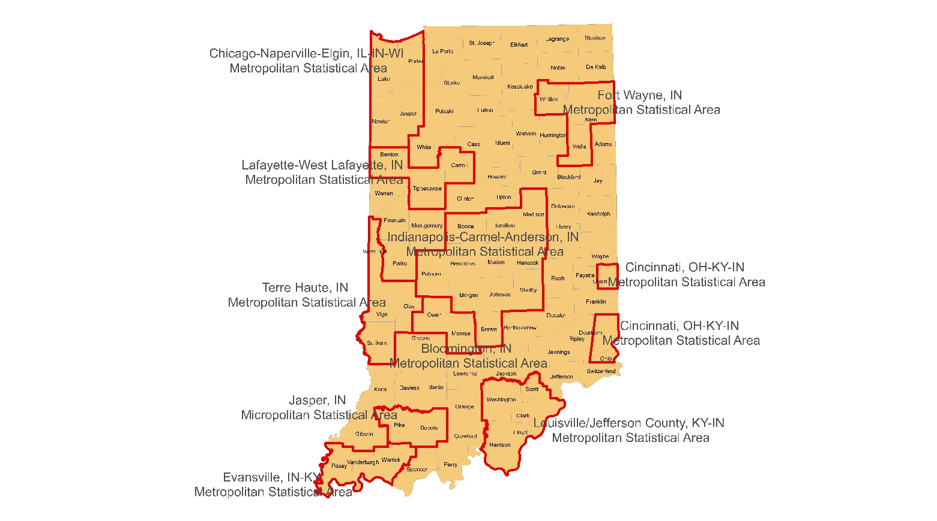

# Current EGR Configuration

Figure 2: Current Economic Growth Regions

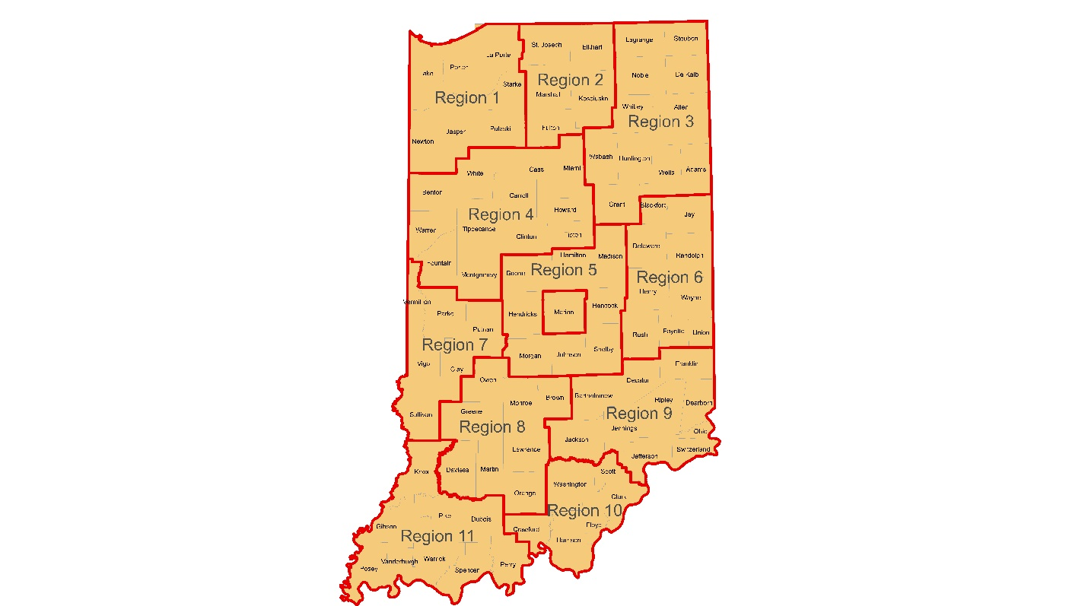

Table 1: Current Economic Growth Regions and Commuting Tightness

|  |  |  |  |  |  |  |  |  |  |  |
| --- | --- | --- | --- | --- | --- | --- | --- | --- | --- | --- |
| EGR 1 | EGR 2 | EGR 3 | EGR 4 | EGR 5 | EGR 6 | EGR 7 | EGR 8 | EGR 9 | EGR 10 | EGR 11 |
| Lake | St. Joseph | LaGrange | Benton | Boone | Blackford | Vermillion | Owen | Franklin | Washington | Knox |
| Newton | Elkhart | Steuben | Warren | Hamilton | Jay | Parke | Monroe | Decatur | Scott | Gibson |
| Porter | Marshall | Noble | Fountain | Madison | Delaware | Putnam | Brown | Bartholomew | Clark | Pike |
| Jasper | Kosciusko | DeKalb | White | Hendricks | Randolph | Vigo | Greene | Jackson | Floyd | Dubois |
| LaPorte | Fulton | Whitley | Tippecanoe | Marion | Henry | Clay | Lawrence | Jennings | Harrison | Posey |
| Starke |  | Allen | Montgomery | Hancock | Wayne | Sullivan | Orange | Ripley | Crawford | Vanderburgh |
| Pulaski |  | Wabash | Carroll | Morgan | Rush |  | Martin | Dearborn |  | Warrick |
|  |  | Huntington | Clinton | Johnson | Fayette |  | Daviess | Ohio |  | Spencer |
|  |  | Wells | Cass | Shelby | Union |  |  | Jefferson |  | Perry |
|  |  | Adams | Miami |  |  |  |  | Switzerland |  |  |
|  |  | Grant | Howard |  |  |  |  |  |  |  |
|  |  |  | Tipton |  |  |  |  |  |  |  |
| 79.9 | 93.5 | 93.0 | 90.1 | 95.7 | 80.5 | 87.0 | 86.8 | 78.9 | 64.8 | 94.8 |

As we can see from the table above, commuting tightness for the current regions is quite good. In fact, the three regions with the worst commuting tightness are 1, 9 and 10. These are all regions that are highly connected to regions outside of the state. Commuting tightness in EGR 6 could also potentially be considered as rather low. This is likely due to the fact that this is one of the more economically depressed regions in the state with few large employment centers leading to a significant amount of commuting to other regions, particularly the suburbs east of Indianapolis. Regarding the low commuting tightness values for regions connected to out-of-state metropolitan areas, commuting tightness values improve significantly if those out-of-state counties are included. For example, if we include those counties outside the state but in the same Labor Market Area for Cincinnati, Louisville, and Chicago, we receive commuting tightness values of the following:

Table 2: Commuting Tightness Including Labor Market Areas Partially Out of State

|  |  |  |
| --- | --- | --- |
| EGR 1 - Chicago | EGR 9 - Cincinnati | EGR 10 - Louisville |
| 95.8 | 91.5 | 94.6 |

This commuting tightness shown in Table 2 highlights that while the commuting tightness is rather low in the original table, it is not due to residents working in other parts of the state. Rather, being attached to neighboring Labor Market Areas in other states lead to those relatively low numbers. In this case, the Chicago, Cincinnati and Louisville Metropolitan Areas. Unsurprisingly, the commuting tightness goes up dramatically when including those out-of-state LMAs, leading us to believe that residents are not commuting to other EGRs, but rather working in a LMA that is comprised of multiple states.

# Current Economic Growth Regions and Labor Market Areas

Figure 3 below highlights the current EGRs and the multi-county Labor Market Areas in the state. Note that Union County is located in EGR 6 while the other Indiana counties that are part of the Cincinnati Labor Market Area are located in EGR 9. Also note that Brown (EGR 8) and Putnam (EGR 7) counties are part of the Indianapolis LMA, but located outside of EGR 5 where the majority of the Indianapolis LMA is located.

Figure 3: Alignment of Current Economic Growth Regions and Labor Market Areas

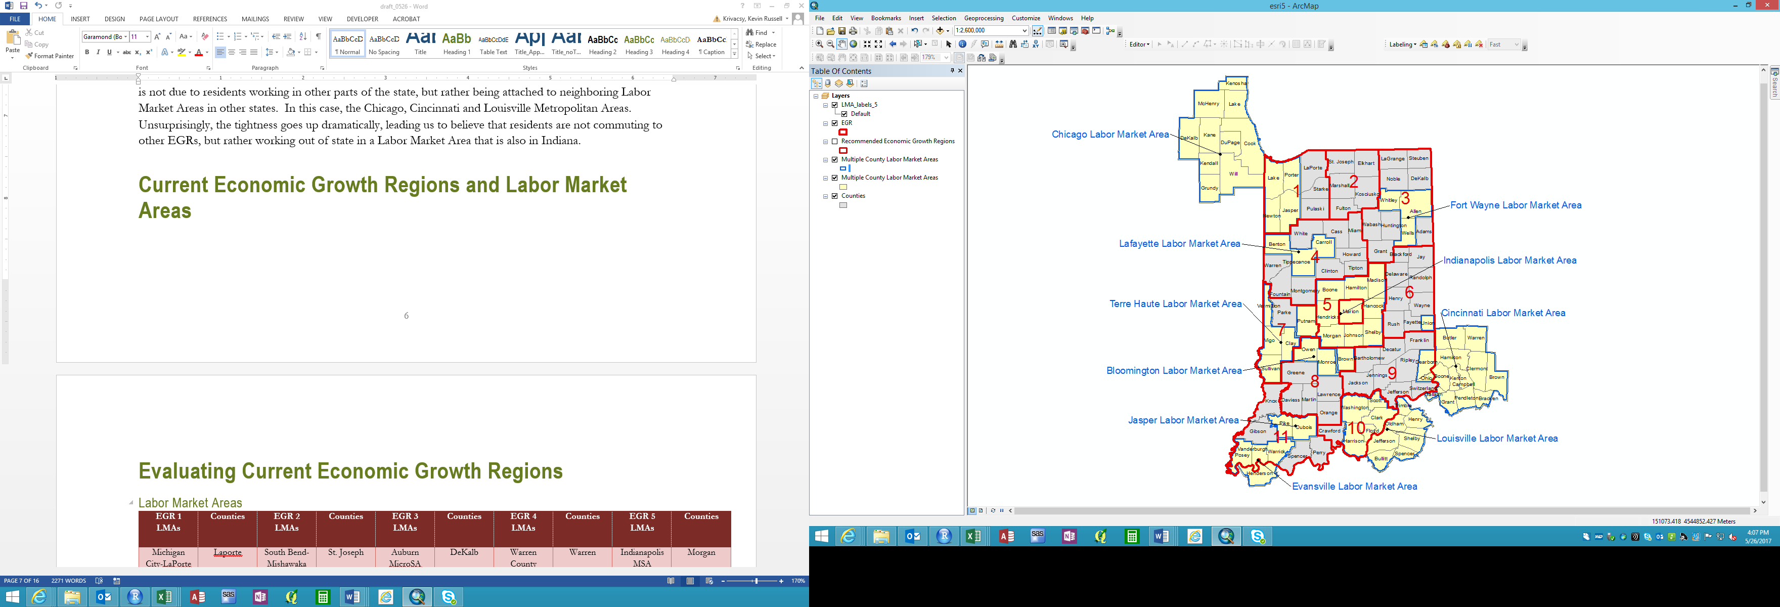



Figure 4: Alignment of Current Economic Growth Regions and Labor Market Areas

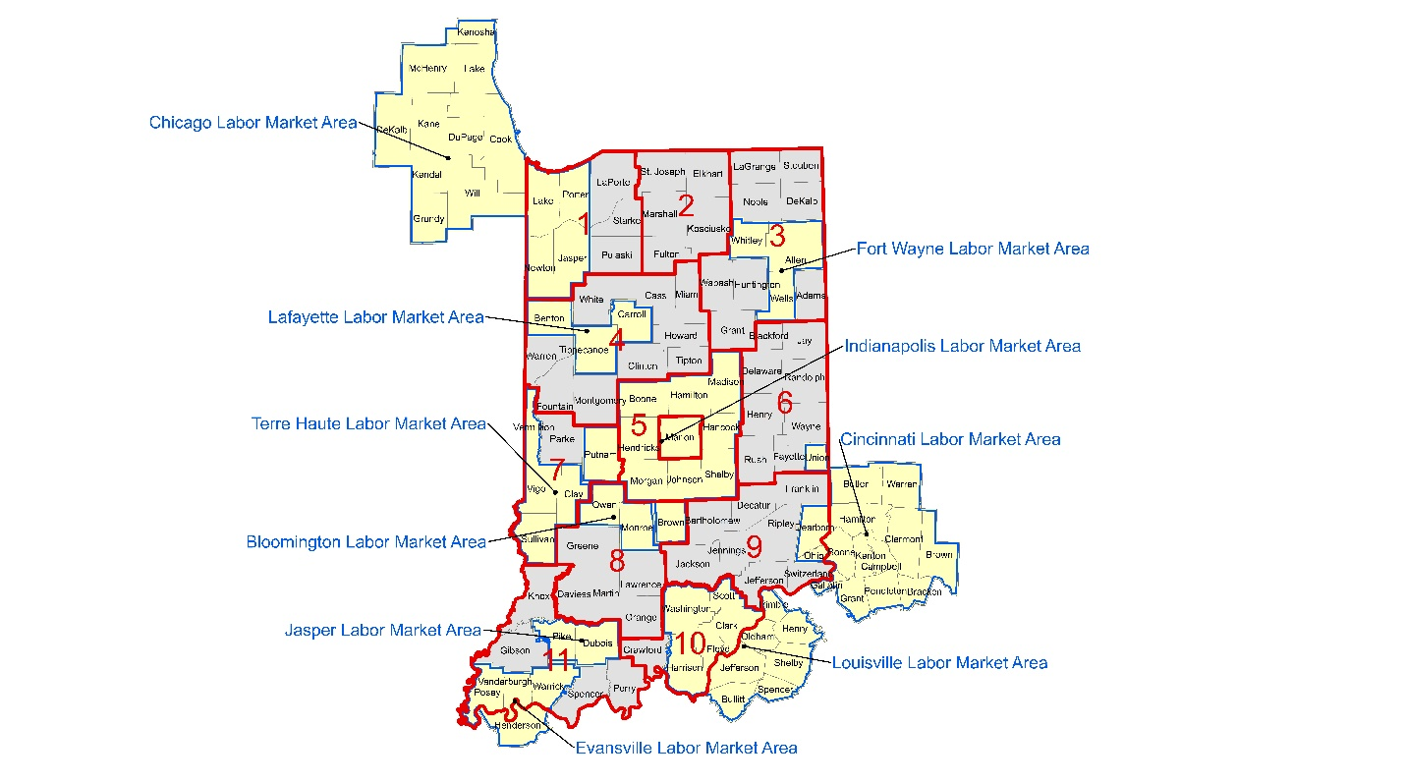

# Evaluating Current Economic Growth Regions

#### Labor Market Areas

Table 3 highlights the county compositions of each LMA and provides the name of the Labor Market Area.

Table 3: County Composition and Names of Labor Market Areas

|  |  |  |  |  |  |  |  |  |  |
| --- | --- | --- | --- | --- | --- | --- | --- | --- | --- |
| EGR 1 LMAs | Counties | EGR 2 LMAs | Counties | EGR 3 LMAs | Counties | EGR 4 LMAs | Counties | EGR 5 LMAs | Counties |
| Michigan City-LaPorte MSA | Laporte | South Bend-Mishawaka MSA | St. Joseph | Auburn MicroSA | DeKalb | Warren County | Warren | Indianapolis MSA | Morgan |
| Starke County | Starke | Plymouth MicroSA | Marshall | Angola MicroSA | Steuben | Fountain County | Fountain |  | Johnson |
| Pulaski County | Pulaski | Fulton County | Fulton | Kendallville MicroSA | Noble | Crawfordsville MicroSA | Montgomery |  | Shelby |
| Chicago MSA | Lake | Elkhart-Goshen MSA | Elkhart | LaGrange County | LaGrange | Frankfort MicroSA | Clinton |  | Hendricks |
|  | Porter | Warsaw MicroSA | Kosciusko | Decatur MicroSA | Adams | Tipton County | Tipton |  | Marion |
|  | Newton |  |  | Huntington MicroSA | Huntington | Kokomo MSA | Howard |  | Hancock |
|  | Jasper |  |  | Wabash MicroSA | Wabash | Peru MicroSA | Miami |  | Boone |
|  |  |  |  | Marion MicroSA | Grant | Logansport MicroSA | Cass |  | Hamilton |
|  |  |  |  | Fort Wayne MSA | Whitley | White County | White |  | Madison |
|  |  |  |  |  | Allen | Lafayette MSA | Benton |  |  |
|  |  |  |  |  | Wells |  | Tippecanoe |  |  |
|  |  |  |  |  |  |  | Carroll |  |  |

Table 4: County Compositions and Names of Labor Market Areas - Part 2

|  |  |  |  |  |  |  |  |  |  |  |  |
| --- | --- | --- | --- | --- | --- | --- | --- | --- | --- | --- | --- |
| EGR 6 LMAs | Counties | EGR 7 LMAs | Counties | EGR 8 LMAs | Counties | EGR 9 LMAs | Counties | EGR 10 LMAs | Counties | EGR 11 LMAs | Counties |
| Blackford County | Blackford | Parke County | Parke | Washington MicroSA | Daviess | Columbus MSA | Bartholomew | Crawford County | Crawford | Jasper MicroSA | Pike |
| Jay County | Jay | Indianapolis MSA | Putnam | Martin County | Martin | Greensburg MicroSA | Decatur | Louisville MSA | Washington |  | Dubois |
| Muncie MSA | Delaware | Terre Haute MSA | Vermillion | Orange County | Orange | Franklin County | Franklin |  | Scott | Vincennes MicroSA | Knox |
| Randolph County | Randolph |  | Vigo | Bedford MicroSA | Lawrence | Seymour MicroSA | Jackson |  | Clark | Gibson County | Gibson |
| New Castle MicroSA | Henry |  | Clay | Greene County | Greene | North Vernon MicroSA | Jennings |  | Floyd | Spencer County | Spencer |
| Richmond MicroSA | Wayne |  | Sullivan | Indianapolis MSA | Brown | Ripley County | Ripley |  | Harrison | Perry County | Perry |
| Rush County | Rush |  |  | Bloomington MSA | Monroe | Madison MicroSA | Jefferson |  |  | Evansville MSA | Posey |
| Connersville MicroSA | Fayette |  |  |  | Owen | Switzerland County | Switzerland |  |  |  | Vanderburgh |
| Cincinnati MSA | Union |  |  |  |  | Cincinnati MSA | Dearborn |  |  |  | Warrick |
|  |  |  |  |  |  |  | Ohio |  |  |  |  |

# Adjusting Economic Growth Regions

There were three counties that were not aligned with the rest of a LMA and moving these counties improved commuting tightness of the EGR without disrupting the commuting tightness of the EGR it moved from. All other LMAs are fully within one EGR in the state. Brown and Putnam counties were moved from their respective EGRs to EGR 5 as they are part of the Indianapolis LMA and most of the Indianapolis LMA is in EGR 5. Therefore, they were moved to be consistent with region 5 representing the Indianapolis LMA. Union County was moved to EGR 9 from EGR 6 to fit better with the Cincinnati LMA. The figure below demonstrates how EGRs should be comprised to align better with LMAs. As we can see from the commuting tightness figures, allowing Brown County to be assigned to EGR 5 instead of EGR 8 actually improves the commuting tightness for EGR 8.

Table 5: Altered Economic Growth Regions to Align with Labor Market Areas – Commuting Tightness

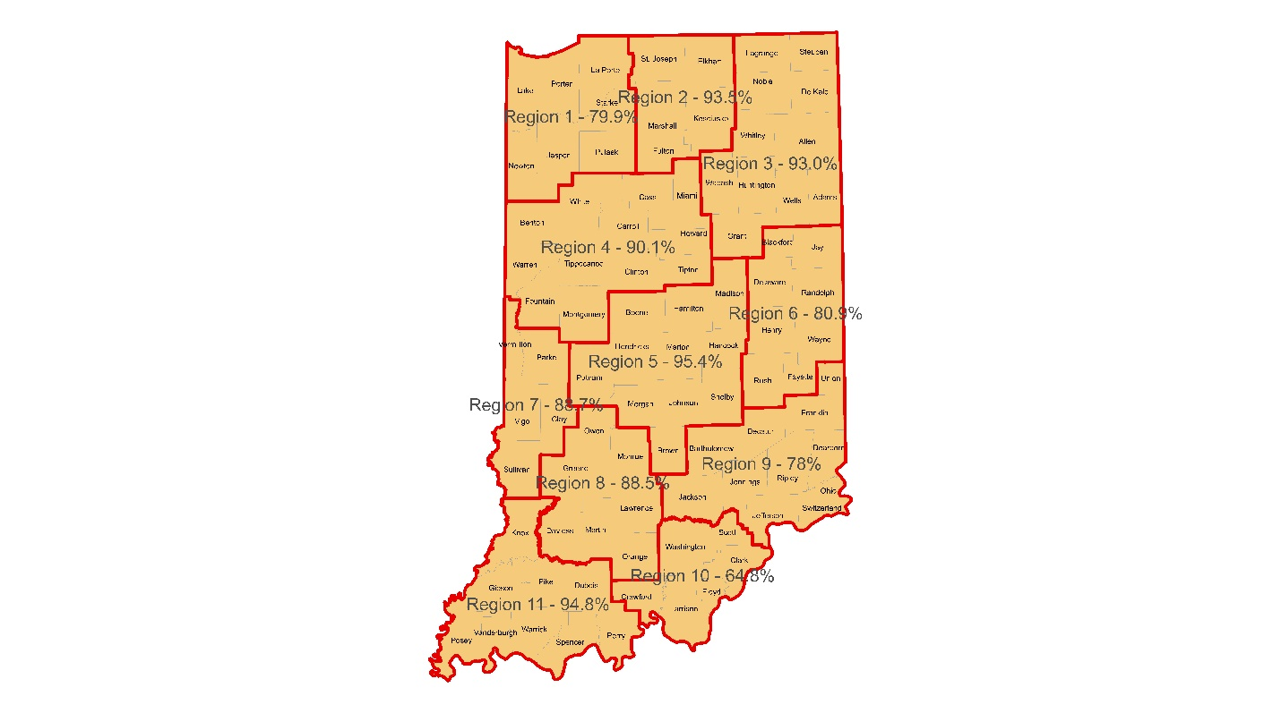

Table 6: Altered Economic Growth Regions to Align with Labor Market Areas - Commuting Tightness

|  |  |  |  |  |  |  |  |  |  |  |
| --- | --- | --- | --- | --- | --- | --- | --- | --- | --- | --- |
| EGR 1 | EGR 2 | EGR 3 | EGR 4 | EGR 5 | EGR 6 | EGR 7 | EGR 8 | EGR 9 | EGR 10 | EGR 11 |
| Lake | St. Joseph | LaGrange | Benton | Boone | Blackford | Vermillion | Owen | Franklin | Washington | Knox |
| Newton | Elkhart | Steuben | Warren | Hamilton | Jay | Parke | Monroe | Decatur | Scott | Gibson |
| Porter | Marshall | Noble | Fountain | Madison | Delaware | Vigo | Greene | Bartholomew | Clark | Pike |
| Jasper | Kosciusko | DeKalb | White | Hendricks | Randolph | Clay | Lawrence | Jackson | Floyd | Dubois |
| LaPorte | Fulton | Whitley | Tippecanoe | Marion | Henry | Sullivan | Orange | Jennings | Harrison | Posey |
| Starke |  | Allen | Montgomery | Hancock | Wayne |  | Martin | Ripley | Crawford | Vanderburgh |
| Pulaski |  | Wabash | Carroll | Morgan | Rush |  | Daviess | Dearborn |  | Warrick |
|  |  | Huntington | Clinton | Johnson | Fayette |  |  | Ohio |  | Spencer |
|  |  | Wells | Cass | Shelby |  |  |  | Jefferson |  | Perry |
|  |  | Adams | Miami | Brown |  |  |  | Switzerland |  |  |
|  |  | Grant | Howard | Putnam |  |  |  | Union |  |  |
|  |  |  | Tipton |  |  |  |  |  |  |  |
| 79.9 | 93.5 | 93.0 | 90.1 | 95.4 | 80.9 | 88.7 | 88.2 | 78.0 | 64.8 | 94.8 |

# Recommended Economic Growth Regions and Labor Market Areas

Ideally, Economic Growth Regions would be adjusted so that they improve commuting tightness (as described by our criteria above) and make it so Labor Market Areas are contained within one Economic Growth Region. Given this mandate, I would recommend a few small changes to current Economic Growth Regions to meet an ideal configuration that maximizes commuting tightness and improves alignment with Labor Market Areas.

First, relocating Brown County from EGR 8 to EGR 5 would allow for an improvement in commuting tightness for both regions and align Brown County with other counties that comprise the Indianapolis Labor Market Area. Relocating Putnam County from EGR 7 to EGR 5 would accomplish the same thing. I would also recommend moving Union County to EGR 9 so that it is aligned with the other Indiana counties that are part of the Cincinnati LMA. While the improvement is slight, I would also consider moving Daviess County from EGR 8 to EGR 11. This is not necessary for alignment with Labor Market Areas, but it does slightly improve overall commuting tightness.

Figure 5: Recommended Economic Growth Regions and Labor Market Areas

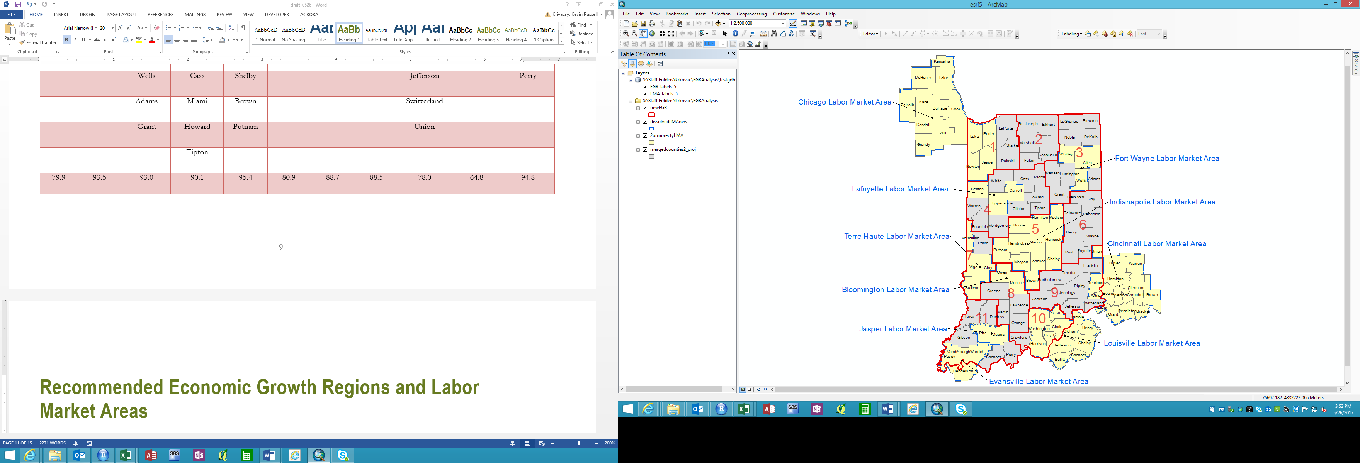



Figure 6: Recommended Economic Growth Regions based on Commuting Tightness and Alignment with Labor Market Areas

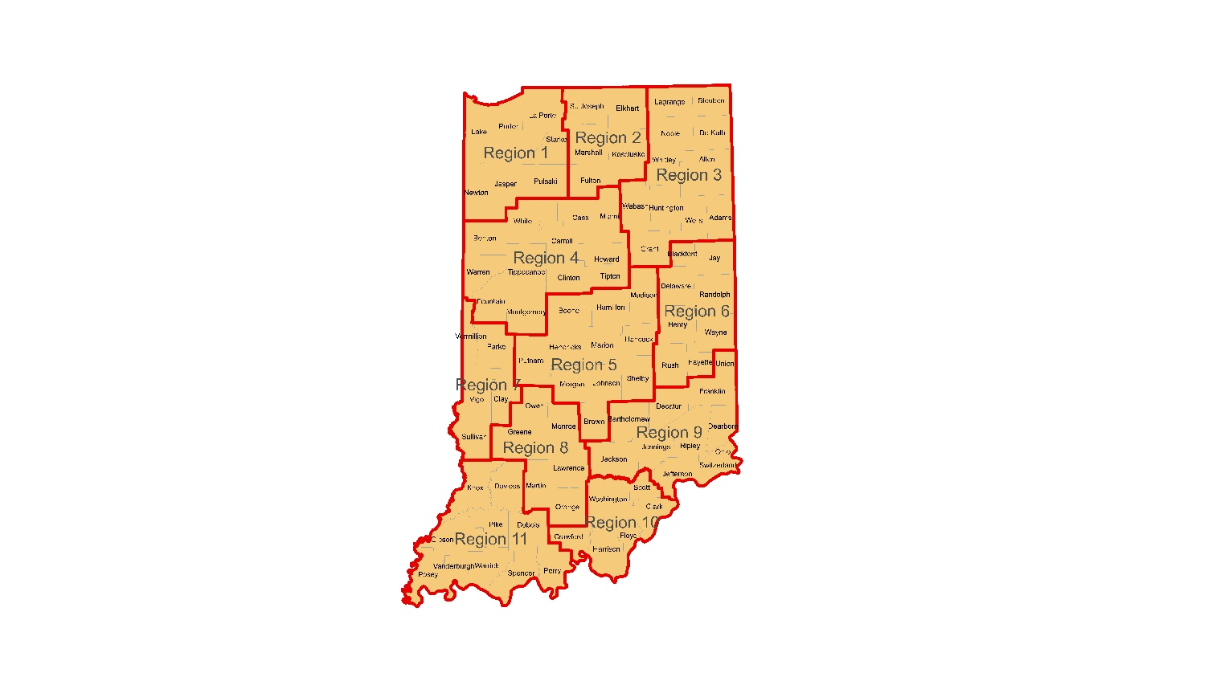

Table 7: Recommended Economic Growth Regions and Commuting Tightness

|  |  |  |  |  |  |  |  |  |  |  |
| --- | --- | --- | --- | --- | --- | --- | --- | --- | --- | --- |
| EGR 1 | EGR 2 | EGR 3 | EGR 4 | EGR 5 | EGR 6 | EGR 7 | EGR 8 | EGR 9 | EGR 10 | EGR 11 |
| Lake | St. Joseph | LaGrange | Benton | Boone | Blackford | Vermillion | Owen | Franklin | Washington | Knox |
| Newton | Elkhart | Steuben | Warren | Hamilton | Jay | Parke | Monroe | Decatur | Scott | Gibson |
| Porter | Marshall | Noble | Fountain | Madison | Delaware | Vigo | Greene | Bartholomew | Clark | Pike |
| Jasper | Kosciusko | DeKalb | White | Hendricks | Randolph | Clay | Lawrence | Jackson | Floyd | Dubois |
| LaPorte | Fulton | Whitley | Tippecanoe | Marion | Henry | Sullivan | Orange | Jennings | Harrison | Posey |
| Starke |  | Allen | Montgomery | Hancock | Wayne |  | Martin | Ripley | Crawford | Vanderburgh |
| Pulaski |  | Wabash | Carroll | Morgan | Rush |  |  | Dearborn |  | Warrick |
|  |  | Huntington | Clinton | Johnson | Fayette |  |  | Ohio |  | Spencer |
|  |  | Wells | Cass | Shelby |  |  |  | Jefferson |  | Perry |
|  |  | Adams | Miami | Brown |  |  |  | Switzerland |  | Daviess |
|  |  | Grant | Howard | Putnam |  |  |  | Union |  |  |
|  |  |  | Tipton |  |  |  |  |  |  |  |
| 79.9 | 93.5 | 93.0 | 90.1 | 95.4 | 80.9 | 88.7 | 88.2 | 78.0 | 64.8 | 94.9 |

# Commuting Tightness with Out-of-State LMAs

Figure 7: Recommended Economic Growth Regions - Commuting Tightness including Out of State Labor Market Areas

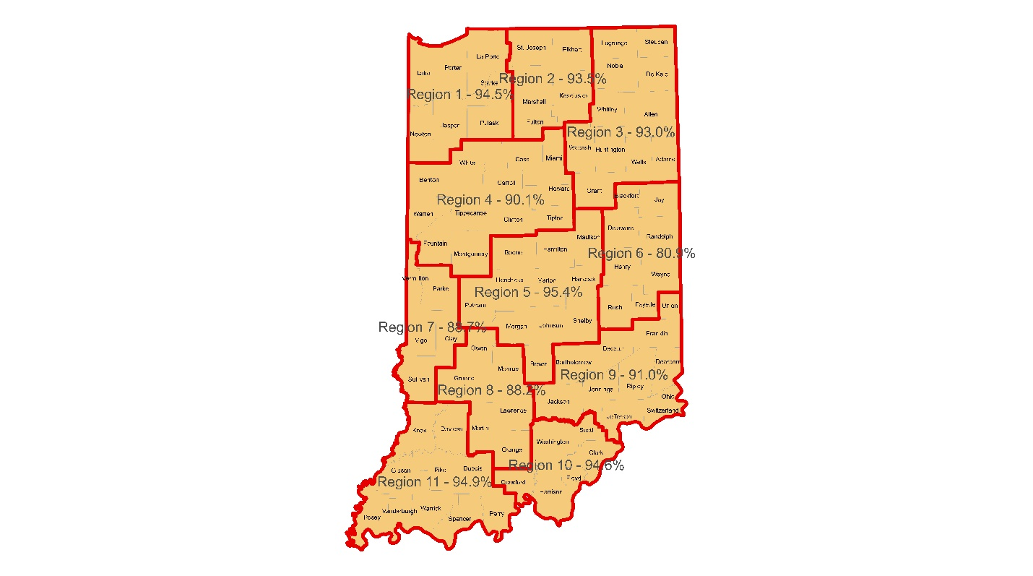

Table 8: Recommended Economic Growth Regions - Commuting Tightness including Out of State Labor Market Areas

|  |  |  |  |  |  |  |  |  |  |  |
| --- | --- | --- | --- | --- | --- | --- | --- | --- | --- | --- |
| EGR 1 | EGR 2 | EGR 3 | EGR 4 | EGR 5 | EGR 6 | EGR 7 | EGR 8 | EGR 9 | EGR 10 | EGR 11 |
| Lake | St. Joseph | LaGrange | Benton | Boone | Blackford | Vermillion | Owen | Franklin | Washington | Knox |
| Newton | Elkhart | Steuben | Warren | Hamilton | Jay | Parke | Monroe | Decatur | Scott | Gibson |
| Porter | Marshall | Noble | Fountain | Madison | Delaware | Vigo | Greene | Bartholomew | Clark | Pike |
| Jasper | Kosciusko | DeKalb | White | Hendricks | Randolph | Clay | Lawrence | Jackson | Floyd | Dubois |
| LaPorte | Fulton | Whitley | Tippecanoe | Marion | Henry | Sullivan | Orange | Jennings | Harrison | Posey |
| Starke |  | Allen | Montgomery | Hancock | Wayne |  | Martin | Ripley | Crawford | Vanderburgh |
| Pulaski |  | Wabash | Carroll | Morgan | Rush |  |  | Dearborn |  | Warrick |
|  |  | Huntington | Clinton | Johnson | Fayette |  |  | Ohio |  | Spencer |
|  |  | Wells | Cass | Shelby |  |  |  | Jefferson |  | Perry |
|  |  | Adams | Miami | Brown |  |  |  | Switzerland |  | Daviess |
|  |  | Grant | Howard | Putnam |  |  |  | Union |  |  |
|  |  |  | Tipton |  |  |  |  |  |  |  |
| 94.5 | 93.5 | 93.0 | 90.1 | 95.4 | 80.9 | 88.7 | 88.2 | 91.0 | 94.6 | 94.9 |

1. WIOA State Plan for the State of Indiana, https://www2.ed.gov/about/offices/list/osers/rsa/wioa/state-plans/in.pdf